DATA ANALYTICS

ASSIGNMENT

Y. PAVAN KUMAR REDDY

20HM1A3542

**DONUT CHART**

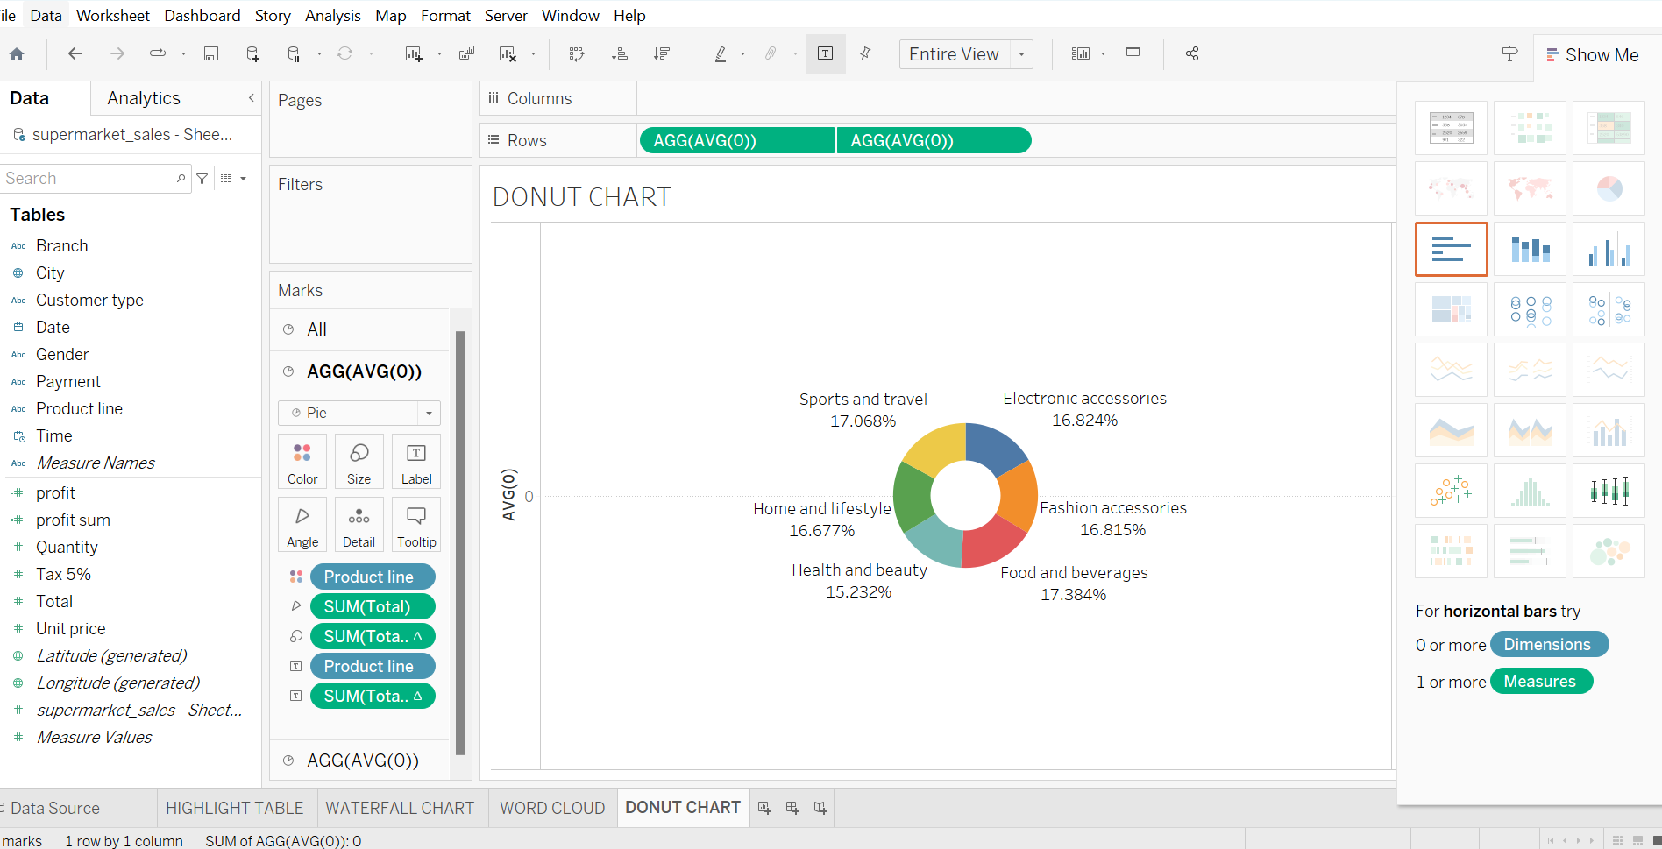

**AREA CHART**

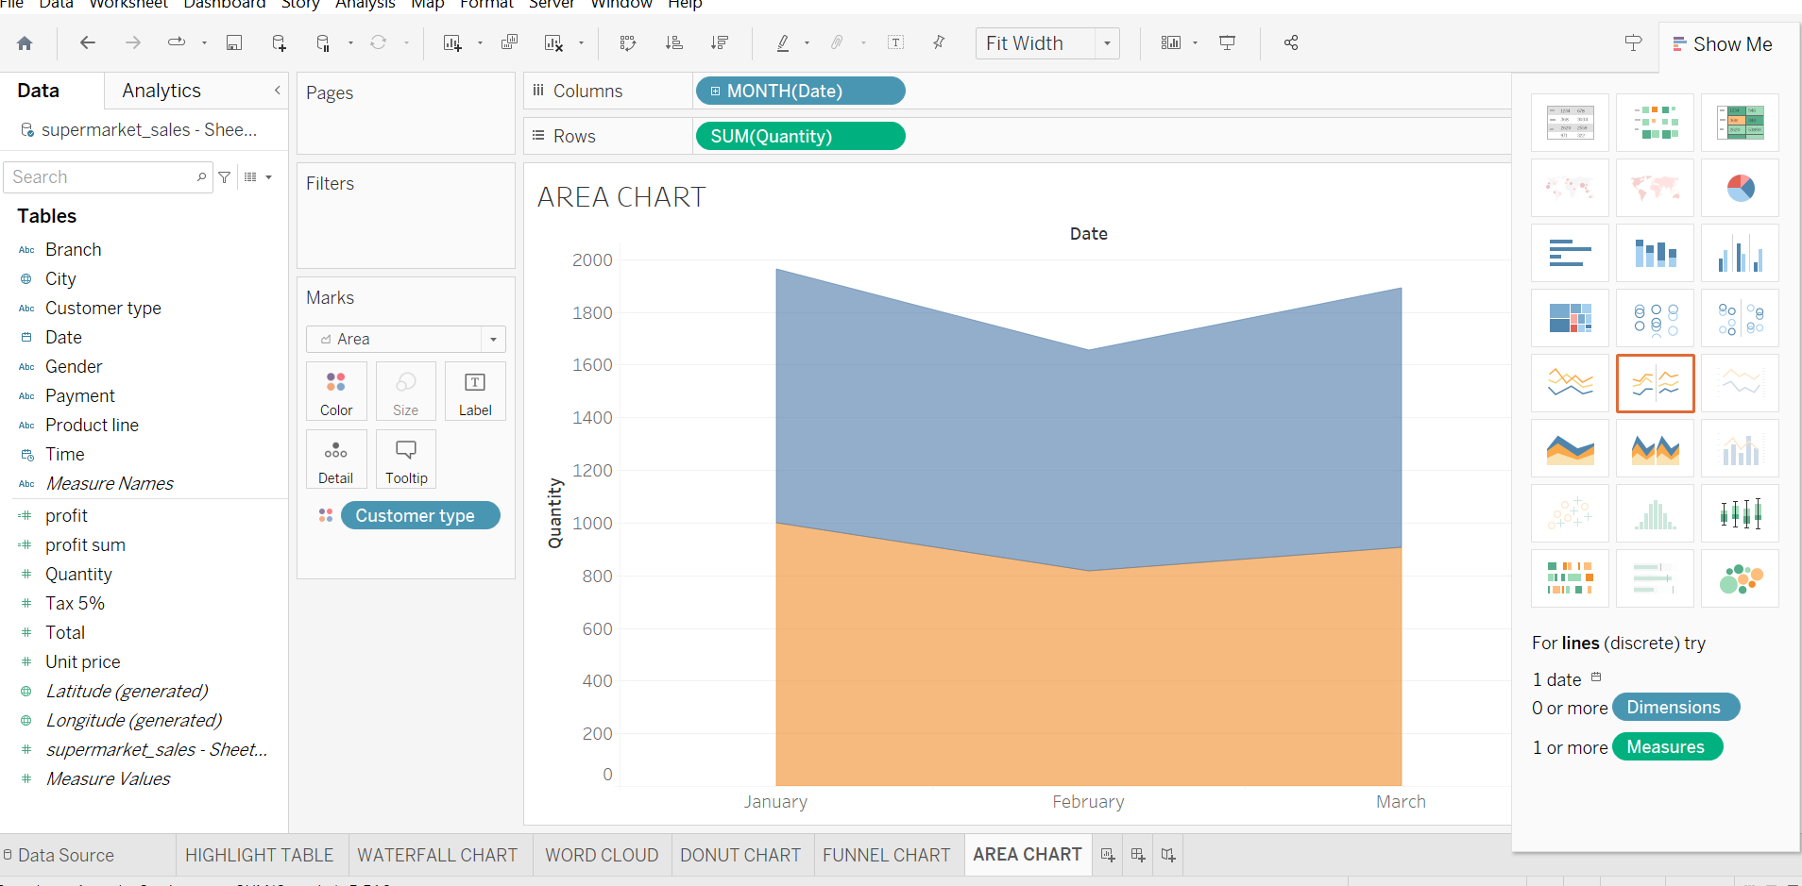

**TEXT TABLE**

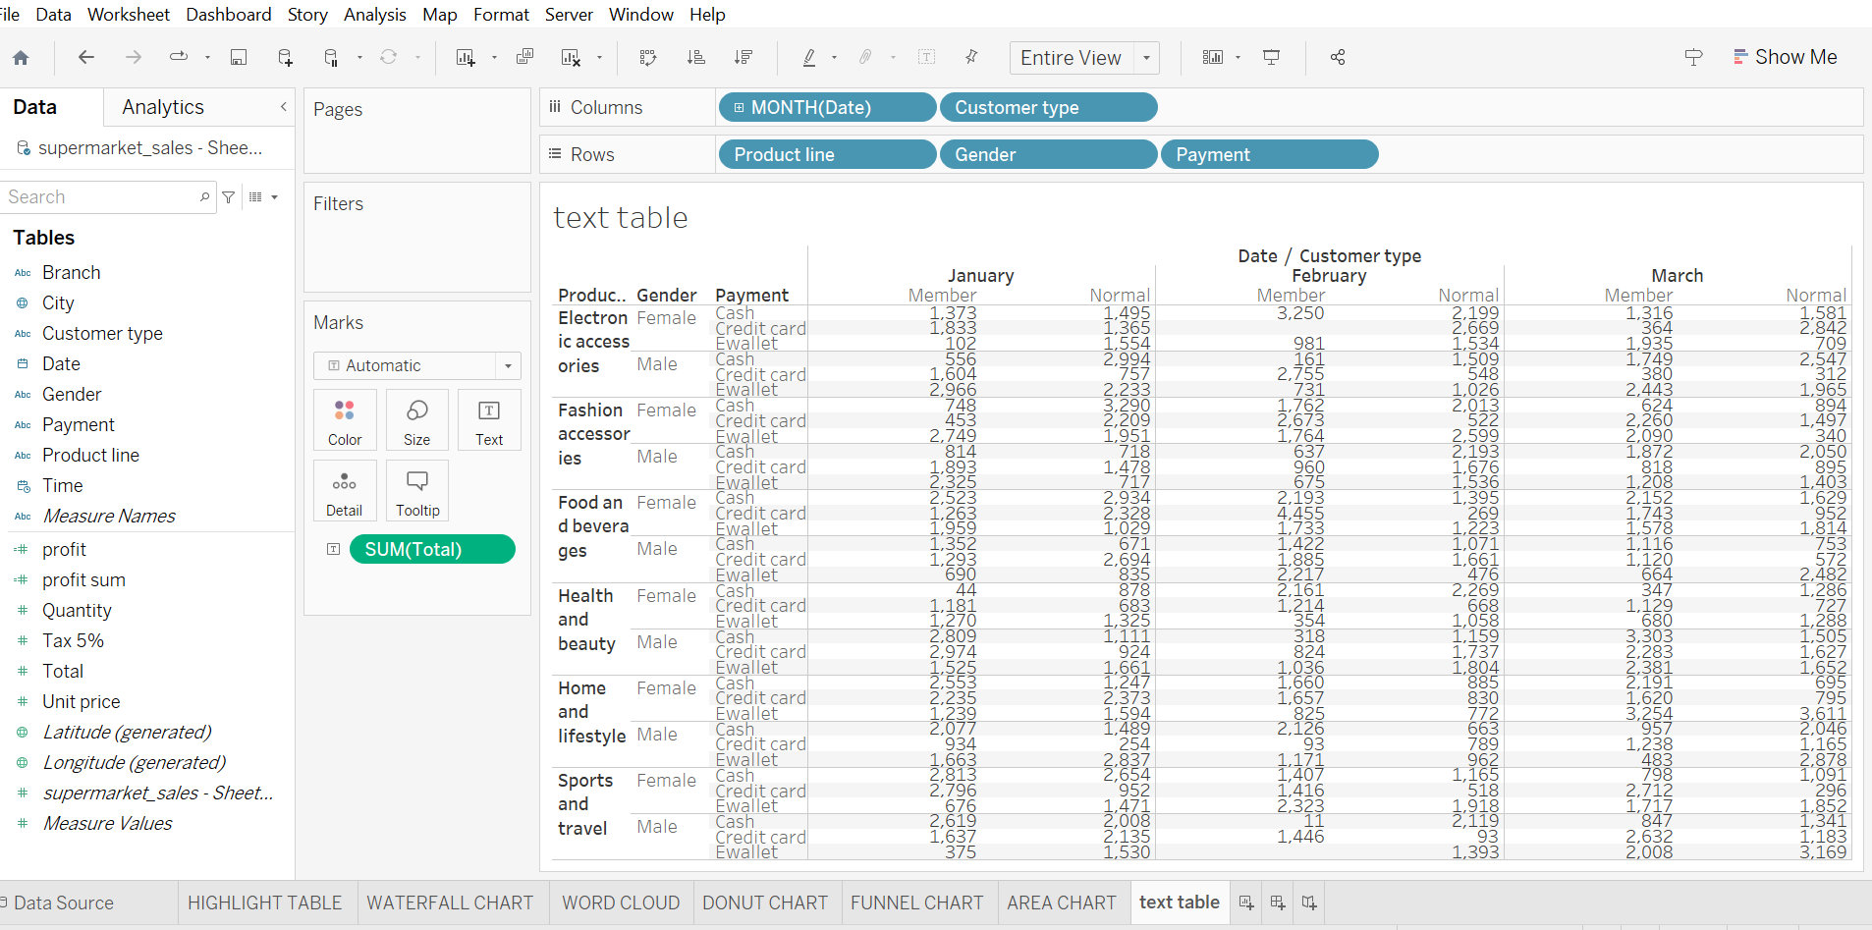

**HIGHLIGHTED TABLE**

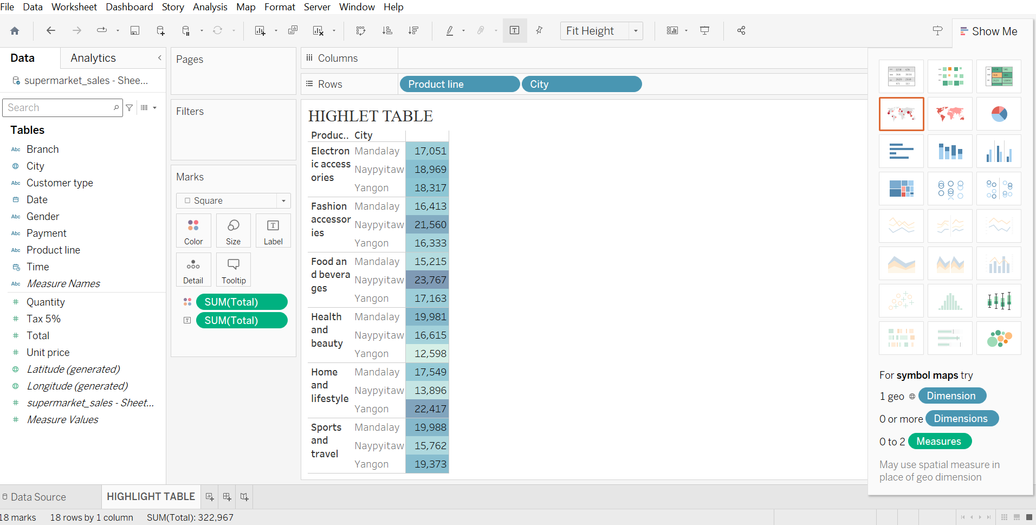

**WORD CLOUD**

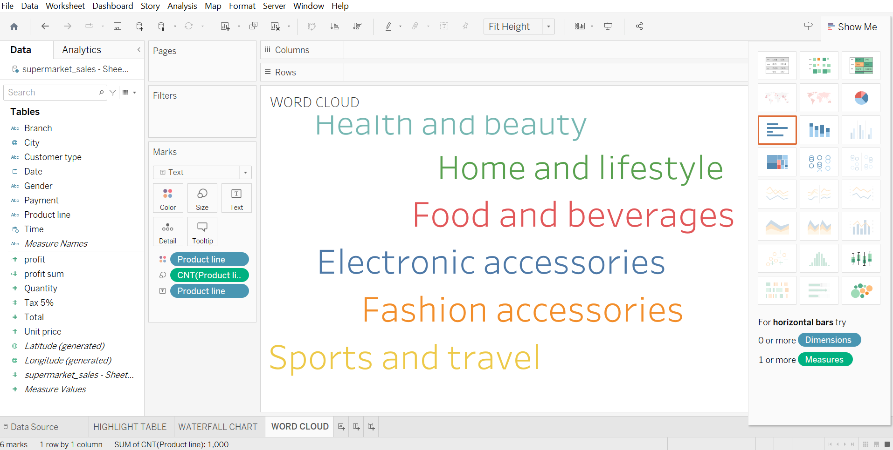

**FUNNEL CHART**

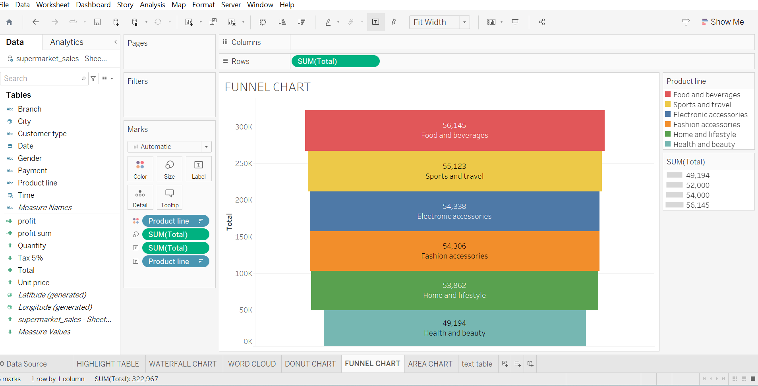

**WATER FALL**

